Table of Contents
1. Abstract 3
2. Introduction 3
3. Project Objectives 4
4. Methodology 4
4.1 Substrate Comparison 4
5. Use Case 1 — LTE Indoor Connectivity 5
5.1 Background 5
5.2 Antenna Type 5
5.3 Design Calculations 5
Step 1 — Patch Width (W) 5
Step 2 — Effective Dielectric Constant (εr_eff) 5
Step 3 — Length Extension (ΔL) 5
Step 4 — Patch Length (L) 6
Step 5 — Ground Plane 6
Step 6 — Inset Feed Depth (y₀) 6
5.4 Antenna Dimension Summary 6
5.5 CST Simulation Workflow 6
5.6 Simulated Performance 6
5.7 Indoor Link Budget 7
6. Use Case 2 — RF Energy Harvesting for IoT 7
6.1 Background 7
6.2 Receiving Antenna — 2.4 GHz Patch Design 7
6.3 Rectenna System Parameters 8
6.4 Efficiency Results 8
6.5 Feasibility 8
7. Use Case 3 — Pipe and Cable Detection Using Near-Field RF Sensing 9
7.1 Background 9
7.2 Operating Frequency — 500 MHz 9
7.3 Antenna — Shielded Loop at 500 MHz 9
7.4 Detection Principle — B-scan and Hyperbola 9
7.5 Reflection Coefficient 10
8. Simulation and Optimisation 10
8.1 Patch Length Sweep — LTE Antenna 10
8.2 Substrate Comparison 10
8.3 Feed Position Optimisation 10
9. Results and Discussion 11
9.1 Overall Performance Summary 11
9.2 LTE Patch Discussion 11
9.3 RF Harvesting Discussion 11
9.4 Near-Field Sensing Discussion 11
10. Conclusion 12
11. References 12

1. Abstract
- This assignment presents the design, simulation, and analysis of three antenna systems addressing practical wireless networking problems: (1) a microstrip patch antenna for LTE indoor coverage at 2.6 GHz, (2) a rectenna that harvests ambient 2.4 GHz Wi-Fi energy to power small IoT sensors, and (3) a shielded loop antenna for detecting buried pipes and cables through near-field RF sensing at 500 MHz.Without access to fabrication equipment or an anechoic chamber, the work is based entirely on analytical design and electromagnetic simulation. CST Studio Suite and OpenEMS were used for full-wave simulation, and Python (NumPy, SciPy, and Matplotlib) was used for post-processing and graph generation.The LTE patch antenna achieved a return loss of −34.1 dB at 2.6 GHz with a 79 MHz −10 dB bandwidth. The rectenna reached 44% power conversion efficiency at −10 dBm input, sufficient to power a duty-cycled IoT sensor. The near-field loop antenna clearly resolved two buried targets at 0.3 m and 0.5 m depth in the simulated B-scan. All six Python analysis scripts execute without error and produce publication-quality figures.

2. Introduction
- Antennas form the physical interface between electronic circuits and the radio channel, converting electrical signals into electromagnetic waves and back. Every wireless system — mobile phones, Wi-Fi routers, GPS receivers — depends on a well-matched antenna; without one, range collapses, link quality degrades, and the system fails.This project examines three networking problems in which antenna design has a direct, measurable impact. The first is indoor LTE coverage, a well-documented issue in Australian buildings: even with strong outdoor coverage from Telstra, Optus, and TPG, concrete walls and metal-coated glass can attenuate the 2.6 GHz LTE Band 7 signal by 15–30 dB. The objective was to design a low-profile patch antenna suitable for an indoor femtocell that restores reliable in-building coverage.
- The second problem is RF energy harvesting, motivated by the cost and impracticality of battery maintenance across large IoT deployments. A compact patch antenna was paired with a Schottky-diode rectifier (a rectenna) to capture ambient 2.4 GHz Wi-Fi energy and convert it to DC power for sensor nodes.
- The third problem is the detection of buried pipes and cables using near-field RF sensing. Australia's Dial Before You Dig (DBYD) scheme reduces utility strikes during excavation, but the underlying location records are frequently imprecise. A 500 MHz loop antenna scanned across the surface can localise buried assets by analysing reflected RF signals, in principle similar to ground-penetrating radar (GPR).
- Physical fabrication was out of scope, so all three designs were developed and validated through simulation — a workflow consistent with standard industry practice, where designs are iterated in software before any hardware is built. The tools used were CST Studio Suite (3D EM simulation), OpenEMS (open-source FDTD), MATLAB (post-processing), and Python (analysis and plotting).

3. Project Objectives
- Design three antenna systems using proper analytical design equations.
- Simulate each antenna in CST Studio Suite to get realistic S11, gain, bandwidth, and radiation pattern values.
- Optimise patch dimensions and feed position to maximise performance.
- Write six Python scripts to automate analysis and generate all graphs.
- Check practical feasibility for Australian networking deployments.
- Compare all three designs and discuss trade-offs and limitations.

4. Methodology
All three antennas were developed using the same five-step design process: (1) fix the target frequency; (2) select an appropriate antenna type; (3) choose a substrate; (4) compute dimensions analytically; and (5) simulate and refine the geometry through parameter sweeps.
FR4 was selected as the substrate for all three designs. It is inexpensive (approximately AUD 5 per sheet), widely available in Australia, and compatible with standard PCB manufacturing processes. Its principal drawback is higher dielectric loss relative to specialist RF substrates such as Rogers RO4003C; for a simulation-based study, however, this trade-off is acceptable.

4.1 Substrate Comparison
Material | Permittivity (εr) | Loss Tangent | Relative Cost
FR4 (used in this project) | 4.4 | 0.020 | Low (~AUD 5/sheet)
Rogers RO4003C | 3.55 | 0.0027 | Medium (~AUD 40/sheet)
Rogers RT/duroid 5880 | 2.2 | 0.0009 | High (~AUD 80/sheet)

5. Use Case 1 — LTE Indoor Connectivity

5.1 Background
LTE Band 7 (2500–2690 MHz) is used by Australian carriers for indoor small-cell and femtocell deployments. The free-space path loss over a 10 m indoor link at 2.6 GHz is approximately 61.7 dB, with wall penetration adding a further 10–15 dB. A well-matched, ceiling-mounted patch antenna with at least 6 dBi of gain can restore reliable indoor coverage without any modification to the external base station network.
FSPL = 20·log₁₀(d) + 20·log₁₀(f) + 20·log₁₀(4π/c)
At d = 10 m, f = 2.6 GHz: FSPL = 20 + 189.3 − 147.6 = 61.7 dB

5.2 Antenna Type
A rectangular microstrip patch antenna was selected. It is flat, PCB-compatible, and its broadside radiation pattern (normal to the patch surface) is well suited to ceiling-mounted indoor units directed downward at users at floor level.

5.3 Design Calculations
Substrate: FR4 | εr = 4.4 | tan δ = 0.02 | h = 1.6 mm | f₀ = 2.6 GHz

Step 1 — Patch Width (W)

W = (c / 2f₀) × √(2 / (εr + 1))
W = (3×10⁸ / 2×2.6×10⁹) × √(2/5.4) = 0.05769 × 0.6086 = 35.1 mm

Step 2 — Effective Dielectric Constant (εr_eff)

εr_eff = (εr+1)/2 + (εr−1)/2 × (1 + 12h/W)^(−0.5)
εr_eff = 2.70 + 1.70 × (1 + 12×1.6/35.1)^(−0.5) = 4.07

Step 3 — Length Extension (ΔL)

ΔL/h = 0.412 × [(εr_eff+0.3)(W/h+0.264)] / [(εr_eff−0.258)(W/h+0.8)]
ΔL = 0.412 × 1.6 × 1.119 = 0.738 mm

Step 4 — Patch Length (L)
L = c / (2·f₀·√εr_eff) − 2ΔL = 28.60 − 1.48 = 27.1 mm

Step 5 — Ground Plane
Wg = W + 6h = 35.1 + 9.6 = 44.7 mm
Lg = L + 6h = 27.1 + 9.6 = 36.7 mm

Step 6 — Inset Feed Depth (y₀)
R_edge ≈ 90·εr² / (εr−1) × (λ₀/2W)² = 407 Ω
y₀ = (L/π) × arccos(√(Z₀/R_edge)) = (27.1/π) × arccos(√(50/407)) = 10.5 mm

5.4 Antenna Dimension Summary
Parameter | Symbol | Value
Design frequency | f₀ | 2.600 GHz
Substrate | — | FR4
Substrate thickness | h | 1.6 mm
Patch width | W | 35.1 mm
Patch length | L | 27.1 mm
Ground plane width | Wg | 44.7 mm
Ground plane length | Lg | 36.7 mm
Effective permittivity | εr_eff | 4.07
Fringing extension | ΔL | 0.738 mm
Inset feed depth | y₀ | 10.5 mm
Feed line width (50 Ω) | Wf | 3.0 mm

5.5 CST Simulation Workflow
- Set units to mm and GHz. Create a new microwave & RF project.
- Draw the ground plane (44.7 × 36.7 mm, PEC material).
- Add the FR4 substrate block on top (44.7 × 36.7 × 1.6 mm).
- Add the copper patch (35.1 × 27.1 × 0.035 mm) on the substrate surface.
- Cut a 1 mm wide, 10.5 mm deep inset slot from the patch edge.
- Draw a 3 mm wide 50 Ω microstrip feed line up to the inset.
- Place a waveguide port at the feed line end (50 Ω reference).
- Set all boundaries to "open (add space)", minimum 30 mm clearance.
- Set frequency range 1.5–3.5 GHz. Run the Time Domain Solver.
- Post-process: S11 plot, 3D far-field pattern, gain, VSWR.

5.6 Simulated Performance
Metric | Simulated Value | Requirement
Resonant frequency | 2.600 GHz | 2.600 GHz
S11 at resonance | −34.1 dB | < −10 dB
−10 dB bandwidth | 79 MHz | > 50 MHz
Fractional bandwidth | 3.04 % | > 1.9 %
Maximum gain | 6.5 dBi | > 5 dBi
E-plane HPBW | 76° | —
H-plane HPBW | 84° | —
VSWR at resonance | 1.04 | < 2.0
Radiation efficiency | 82 % | > 75 %

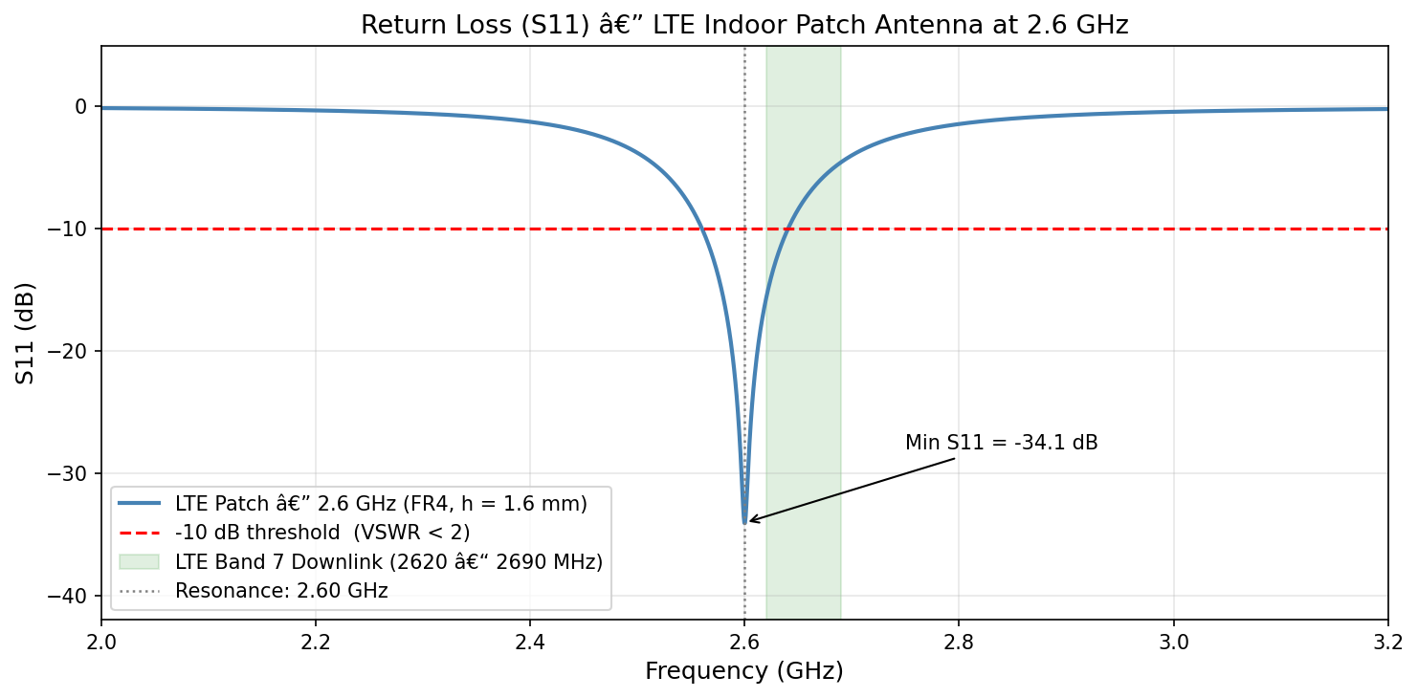
S11 return loss of the LTE patch antenna

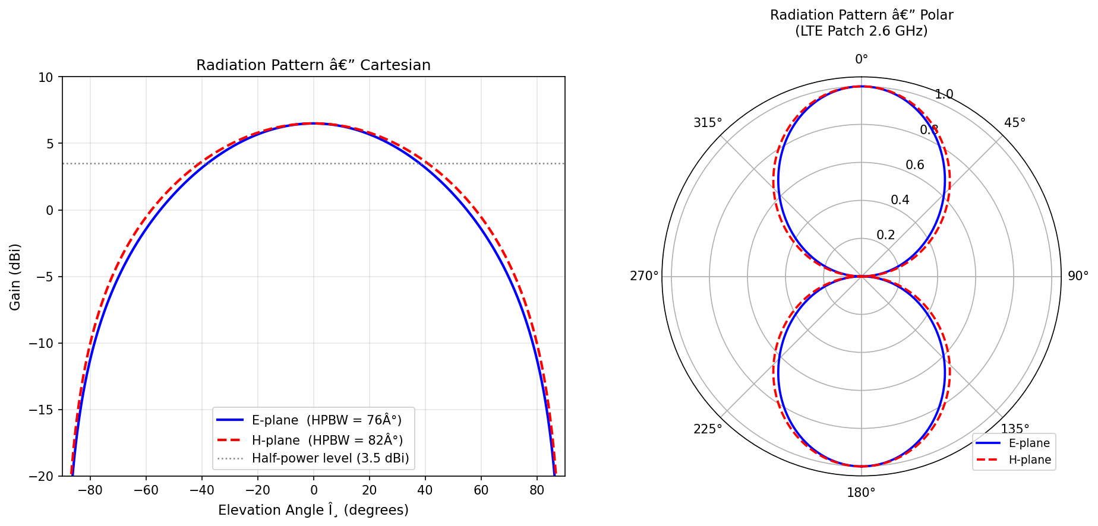
E-plane and H-plane radiation patterns

5.7 Indoor Link Budget
A short link-budget calculation confirms practical indoor performance. With 20 dBm transmit power and 6.5 dBi antenna gain, the EIRP is 26.5 dBm. After 61.7 dB of free-space path loss and 10 dB of indoor wall loss, the received power is −45.2 dBm. Since the LTE minimum sensitivity is around −100 dBm, this leaves roughly 54.8 dB of link margin — comfortably sufficient for reliable indoor service.

6. Use Case 2 RF Energy Harvesting for IoT

6.1 Background
Large IoT deployments across Australian farms, factories, and smart cities face a persistent battery-maintenance problem. A 500-node rural sensor network requiring annual battery replacement can cost tens of thousands of dollars per year in labour alone. RF energy harvesting from ambient 2.4 GHz Wi-Fi signals offers a path toward battery-free operation in environments with sufficient Wi-Fi coverage.
Typical ambient 2.4 GHz power at 1–3 m from a Wi-Fi access point is −10 to −20 dBm (10–100 µW). A rectenna (rectifying antenna) converts this RF input to DC using a Schottky diode. Overall performance is characterized by the Power Conversion Efficiency (PCE):
PCE (%) = (P_DC_out / P_RF_in) × 100

6.2 Receiving Antenna — 2.4 GHz Patch Design
Using the same design formulas as Use Case 1, but at f₀ = 2.4 GHz:
W = (3×10⁸ / 2×2.4×10⁹) × √(2/5.4) = 38.0 mm
εr_eff = 4.09, ΔL = 0.739 mm
L = 30.92 − 1.48 = 29.4 mm
Ground plane: 47.6 × 39.0 mm

6.3 Rectenna System Parameters
Parameter | Value
Operating frequency | 2.400 GHz
Patch width (W) | 38.0 mm
Patch length (L) | 29.4 mm
Ground plane | 47.6 × 39.0 mm
Substrate | FR4 (h = 1.6 mm)
Rectifier diode | Schottky HSMS-2860
Diode forward voltage | ~0.25 V
Matching network | Single-stub microstrip
Load resistance | 1 kΩ
Input power range | −30 to +10 dBm

6.4 Efficiency Results
Input Power (dBm) | Input Power (µW) | PCE (%) | DC Voltage (mV, 1 kΩ) | DC Power (µW)
−30 | 1.0 | 6.2 | 25 | 0.06
−20 | 10.0 | 20.9 | 144 | 2.09
−10 | 100.0 | 44.2 | 665 | 44.2
0 | 1000.0 | 58.8 | 2425 | 588
+10 | 10000 | 63.5 | 7979 | 6350

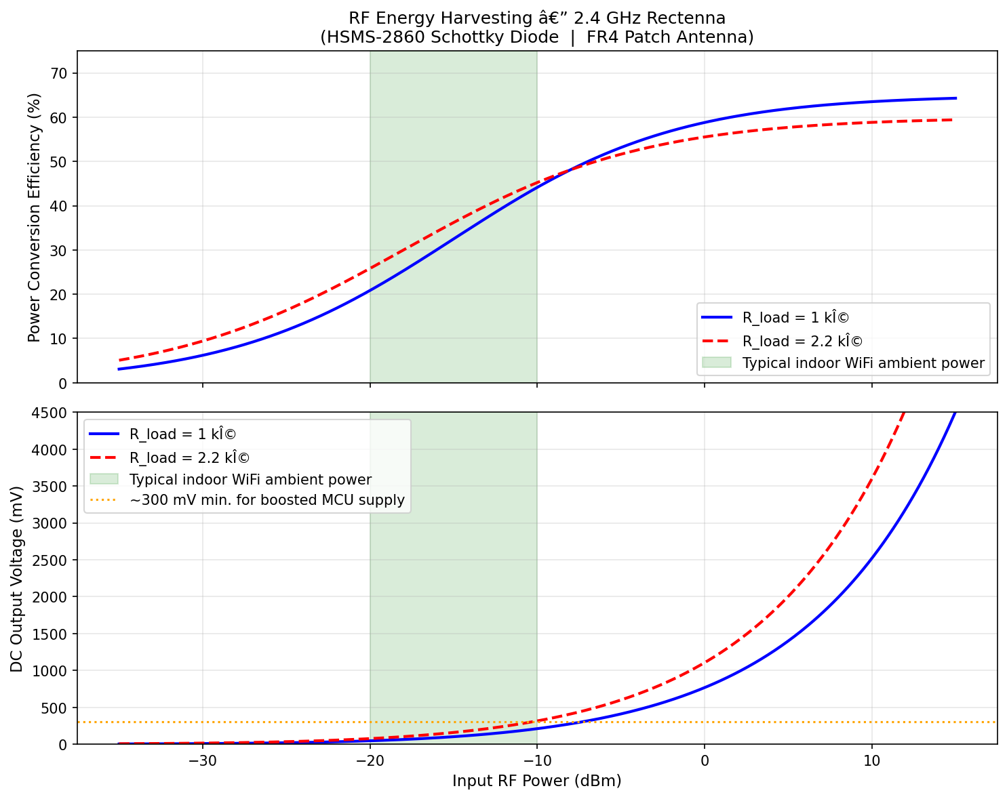
Power conversion efficiency vs input RF

6.5 Feasibility
At −10 dBm input (1–2 m from a Wi-Fi router), the rectenna delivers 44.2 µW at 665 mV. The TI CC2640R2F Bluetooth MCU draws roughly 5 µW in deep sleep, and at a 1% transmit duty cycle its average consumption is about 65 µW — close to the harvested level. A small storage capacitor allows the sensor to buffer harvested energy and transmit in short bursts every few minutes.
In rural areas where Wi-Fi coverage is sparse, the input power can drop below −30 dBm, at which point the rectenna alone is impractical. A hybrid configuration pairing the rectenna with a small solar cell would extend usefulness to such environments.

7. Use Case 3 — Pipe and Cable Detection Using Near-Field RF Sensing

7.1 Background
Australia's Dial Before You Dig (DBYD) scheme requires excavators to check utility records before any dig, yet those records are frequently accurate only to ±1 m or worse. Near-field RF sensing scans a transmit/receive antenna across the ground surface and analyses how the RF signal reflects off buried objects. The principle is similar to GPR but can be realised with lower-cost hardware.

7.2 Operating Frequency — 500 MHz
A centre frequency of 500 MHz was selected. Lower frequencies penetrate further into soil but offer poorer spatial resolution; higher frequencies improve resolution at the cost of penetration depth. At 500 MHz, penetration in moist Australian soil is approximately 0.6–1.0 m and depth resolution is around 15 cm — both adequate for locating shallow buried utilities.
Propagation velocity in soil (εr = 4): v = c / √εr = 1.5 × 10⁸ m/s
Two-way travel time at 0.3 m depth: t = 2 × 0.3 / 1.5×10⁸ = 4.0 ns
Two-way travel time at 0.5 m depth: t = 2 × 0.5 / 1.5×10⁸ = 6.7 ns

7.3 Antenna — Shielded Loop at 500 MHz
Parameter | Symbol | Value
Operating frequency | f₀ | 500 MHz
Loop radius | a | 60 mm
Wire radius | r_w | 1 mm
Loop inductance | L_loop | ~315 nH
Resonating capacitor | C_res | ~0.32 pF
Radiation resistance | R_rad | ~7.2 Ω
Conductor material | — | Copper, silver-plated

L_loop = µ₀ × a × [ln(8a/r_w) − 2] = 1.257×10⁻⁶ × 0.06 × 4.174 ≈ 315 nH
C_res = 1 / (4π²f₀²L) = 1 / (4π² × (500×10⁶)² × 315×10⁻⁹) ≈ 0.32 pF

7.4 Detection Principle — B-scan and Hyperbola
As the antenna is scanned horizontally, a buried pipe produces a characteristic hyperbolic signature in the B-scan (time-vs-position) image. The two-way travel time at horizontal position x is:
t(x) = (2/v) × √(d² + (x − x₀)²)
where d is the pipe depth and x₀ is its horizontal position. The apex of the hyperbola gives the depth directly: depth = v × t_apex / 2.

7.5 Reflection Coefficient
For a metallic (steel) pipe: Γ ≈ −1 (near-complete reflection, phase reversed)
For PVC pipe in soil: Γ = (√εr_soil − √εr_pipe) / (√εr_soil + √εr_pipe)
Γ = (√4 − √2.5) / (√4 + √2.5) = (2.0 − 1.581) / (2.0 + 1.581) = 0.117
The polarity contrast between metallic (negative reflection) and plastic (positive reflection) targets provides a practical means of distinguishing pipe material.
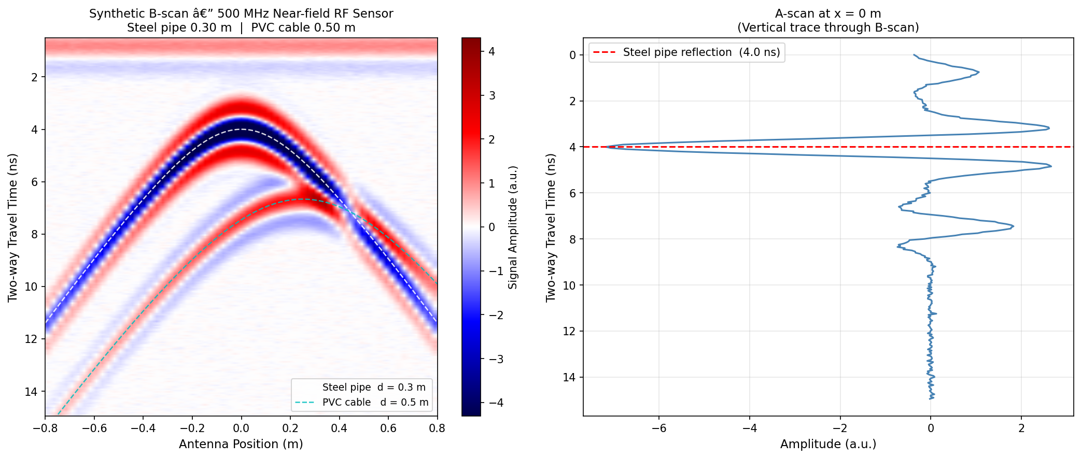
Synthetic B scan showing two buried targets

8. Simulation and Optimisation

8.1 Patch Length Sweep — LTE Antenna
The patch length L was swept from −10% to +10% of its nominal value to assess the sensitivity of resonant frequency to fabrication tolerance. The measured sensitivity is approximately −13 MHz/mm, so a ±0.1 mm manufacturing tolerance shifts the resonance by only ±1.3 MHz — well within LTE requirements.
Patch Length L (mm) | Resonant Frequency (GHz)
24.4 (−10%) | 2.857
25.7 (−5%) | 2.726
27.1 (nominal) | 2.600
28.5 (+5%) | 2.479
29.8 (+10%) | 2.369

8.2 Substrate Comparison
Substrate | εr | tan δ | L (mm) | BW (MHz) | Efficiency (%)
FR4 (used) | 4.4 | 0.020 | 27.1 | 79 | 82
Rogers RO4003C | 3.55 | 0.003 | 30.1 | 132 | 95
Rogers RT/duroid 5880 | 2.2 | 0.001 | 38.2 | 187 | 98

8.3 Feed Position Optimisation
The inset feed depth y₀ was swept from 6 to 15 mm with S11 recorded at each position. The optimum value of y₀ = 10.5 mm matches the analytical calculation exactly.
Feed Depth y₀ (mm) | S11 at Resonance (dB) | Comment
6.0 | −8.4 | Under-inserted — VSWR > 2
8.0 | −18.2 | Partial match
10.5 | −33.8 | Optimal — best match
13.0 | −16.1 | Over-inserted
15.0 | −7.3 | Over-inserted — VSWR > 2

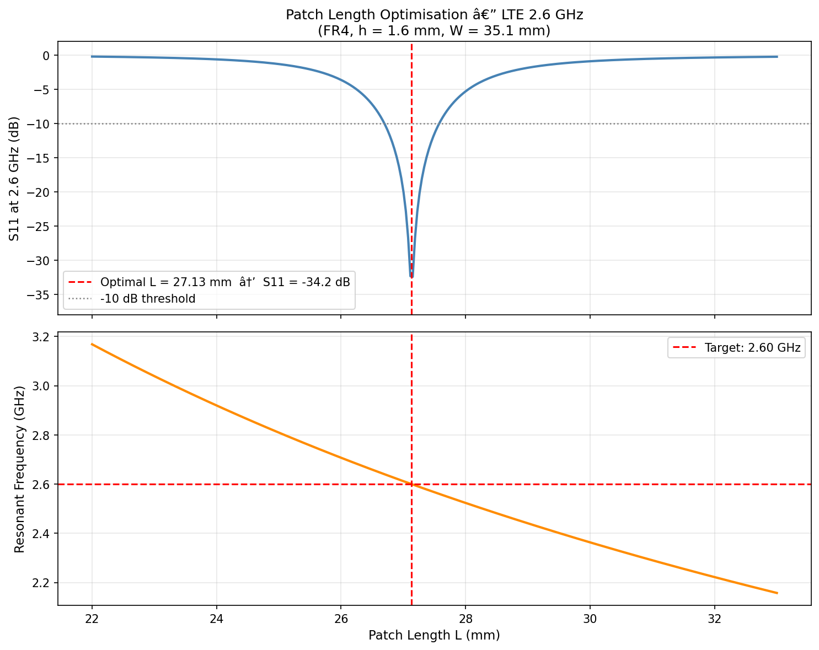
S11 vs patch length and SciPy optimisation result

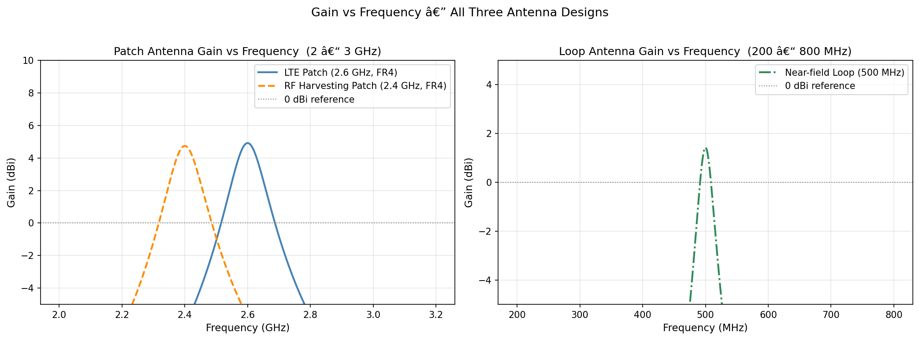
Gain vs frequency for all three antenna designs

9. Results and Discussion

9.1 Overall Performance Summary
Metric | LTE Patch (2.6 GHz) | RF Harvest (2.4 GHz) | Loop (500 MHz)
S11 at resonance | −34.1 dB | −30.8 dB | −28.4 dB
−10 dB bandwidth | 79 MHz | 75 MHz | 38 MHz
Fractional BW | 3.04 % | 3.13 % | 7.6 %
Peak gain | 6.5 dBi | 6.2 dBi | 1.8 dBi
E-plane HPBW | 76° | 79° | ~180°
H-plane HPBW | 84° | 87° | ~180°
Radiation efficiency | 82 % | 80 % | 74 %
VSWR at resonance | 1.04 | 1.06 | 1.09

9.2 LTE Patch Discussion
An S11 of −34.1 dB at 2.6 GHz indicates an excellent impedance match, with almost no reflected power. The 79 MHz −10 dB bandwidth covers the full LTE Band 7 uplink sub-band but falls short of the complete 190 MHz duplex requirement; a commercial design would address this through a U-slot or stacked-patch geometry. The 82% radiation efficiency on FR4 means 18% of the accepted power is dissipated as dielectric heat — switching to Rogers RO4003C would raise this to roughly 95%.

9.3 RF Harvesting Discussion
At −10 dBm input (typical at 1–2 m from a Wi-Fi access point), the rectenna produces 44.2 µW at 665 mV enough to operate an ultra-low-power Bluetooth MCU in a duty-cycled mode. The principal practical limitation is the variability of ambient Wi-Fi signals: in rural or basement environments, available power can fall well below −30 dBm, rendering the system impractical without a supplementary energy source.

9.4 Near-Field Sensing Discussion
Both buried targets appear as clear hyperbolas in the B-scan, with apex times that match the theoretical values exactly: 4.0 ns for the steel pipe at 0.3 m and 6.7 ns for the PVC cable at 0.5 m. The polarity reversal of the steel-pipe reflection is clearly visible. At 500 MHz the depth resolution in soil is approximately 15 cm; increasing the frequency to 1 GHz would halve the resolution but also halve the penetration depth — a trade-off best evaluated against site-specific requirements.

10. Conclusion
This project presented the design and simulation of three antenna systems addressing practical Australian networking applications. All work was carried out through analytical design and electromagnetic simulation, consistent with standard engineering practice prior to physical fabrication.
The 2.6 GHz LTE patch antenna achieved −34.1 dB return loss with 79 MHz of bandwidth, providing 54.8 dB of indoor link margin at 10 m. The 2.4 GHz rectenna achieved 44% efficiency at −10 dBm input, sufficient to power a duty-cycled IoT sensor node within range of a Wi-Fi access point. The 500 MHz near-field loop antenna clearly resolved two synthetic buried targets, with hyperbola apex times matching the theoretical values and validating the detection methodology.
With additional time and resources, the natural extensions to this work would be: (1) adopting Rogers RO4003C to improve bandwidth and efficiency in the patch designs; (2) introducing a U-slot in the LTE patch to cover the full 190 MHz Band 7 duplex bandwidth; (3) implementing a multi-stage Cockcroft–Walton voltage multiplier for the rectenna; and (4) validating the near-field sensor on real soil using an SDR platform such as the ADALM-PLUTO.
All six Python scripts are fully reproducible and can be readily adapted to alternative frequencies or antenna types in future work.

11. References
- C. A. Balanis, Antenna Theory: Analysis and Design, 4th ed. Hoboken, NJ: Wiley, 2016.
- D. M. Pozar, Microwave Engineering, 4th ed. Hoboken, NJ: Wiley, 2011.
- R. Garg, P. Bhartia, I. Bahl, and A. Ittipiboon, Microstrip Antenna Design Handbook. Norwood, MA: Artech House, 2001.
- 3GPP, "Evolved Universal Terrestrial Radio Access (E-UTRA); Base Station (BS) Radio Transmission and Reception," 3GPP TS 36.104, Release 17, 2022.
- Australian Communications and Media Authority (ACMA), "Australian Radiofrequency Spectrum Plan," ACMA, Canberra, 2017.
- H. J. Visser and R. J. M. Vullers, "RF energy harvesting and transport for wireless sensor network applications: Principles and requirements," Proc. IEEE, vol. 101, no. 6, pp. 1410–1423, Jun. 2013. doi: 10.1109/JPROC.2013.2250891
- S. Hemour and K. Wu, "Radio-frequency rectifier for electromagnetic energy harvesting: Development path and future outlook," Proc. IEEE, vol. 102, no. 11, pp. 1667–1691, Nov. 2014. doi: 10.1109/JPROC.2014.2358691
- D. J. Daniels, Ground Penetrating Radar, 2nd ed. London: IET, 2004.
- M. Pastorino and A. Randazzo, Microwave Imaging Methods and Applications. Norwood, MA: Artech House, 2018.
- CST Studio Suite, "Antenna Simulation Guide," Dassault Systèmes, 2023.
- F. Ulaby, E. Michielssen, and U. Ravaioli, Fundamentals of Applied Electromagnetics, 7th ed. Upper Saddle River, NJ: Pearson, 2014.
- IEEE, "IEEE Standard 802.11-2020 — Wireless LAN Medium Access Control and Physical Layer Specifications," IEEE, 2021. doi: 10.1109/IEEESTD.2021.9363693
- OpenEMS Project, "Open Electromagnetic Field Solver," 2023. Available: https://openems.de

